ATLANTIQUE ® 50 2005 BASE PRICE LIST

EX FACTORY

ENGINE OPTIONS

Single Lugger 6108 A2 300 bhp $922,995

Single Lugger 6108 A2 300 bhp + Wing Engine $947,995*

Twin Lugger 668T 165 bhp $960,995*

OPTIONS

- Fly bridge $26,995
- Navigation Electronics T.B.A.
- Passerelle T.B.A.

Distributor: -
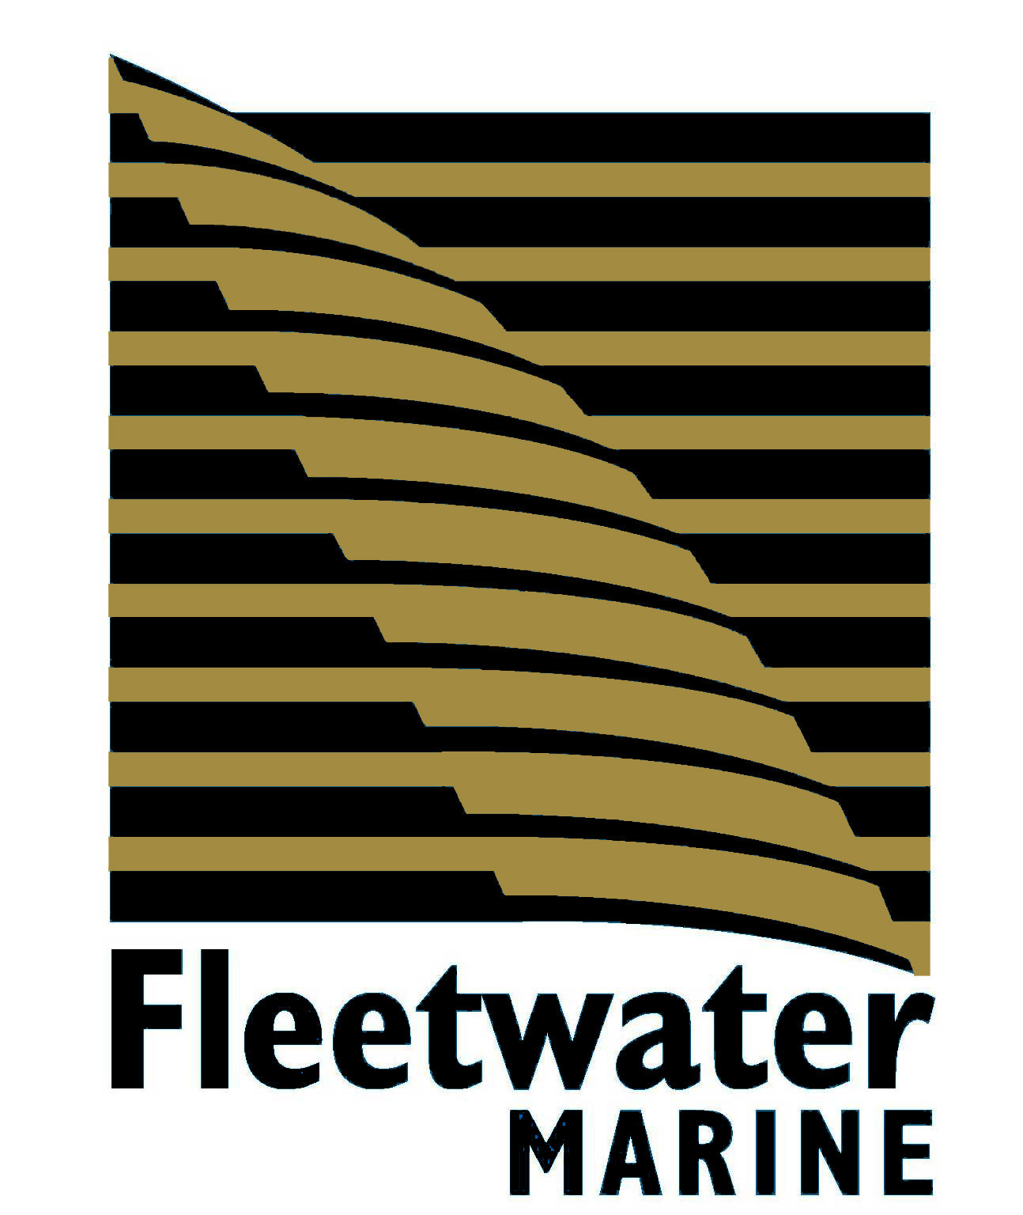

Ocean Quay Marina
Belvidere Road
Southampton SO14 5QY
United kingdom

TEL: +44 (0) 23 8023 5421 FAX: +44 (0) 23 8023 5436
E-mail: sales@fleetwatermarine.com

